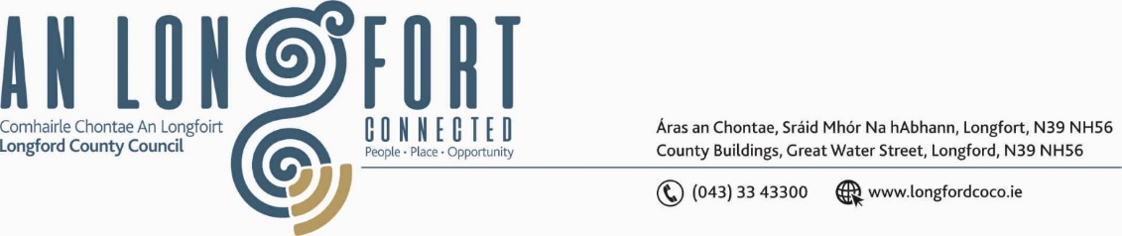

***BALLYMAHON MUNICIPAL DISTRICT***

***Please note meeting will be held in Ballymahon Library.***

**17 May 2023.**

**To: Each Member of Ballymahon Municipal District.**

**Dear Member,**

You are requested to attend a Meeting of Ballymahon Municipal District to be held

**in Ballymahon Library** on **Thursday 25 May 2023 at 4pm** to transact business, as set out on the agenda hereunder.

**Yours sincerely**,

_______________

**Claire McNabola,**

**Meetings Administrator.**

**AGENDA**

Prayer before meeting.

**1.** Confirmation of Minutes of Ballymahon Municipal District Meeting held on the 23 March 2023 – enclosed.

**2.** Matters arising from Minutes

**3.** Declaration of Interest by Members

**4**. Management Report – enclosed

**5**. Briefing on the N55 Athlone to Ballymahon Preferred Route Corridor

**6. Notices of Motions, submitted by Councillors, as listed hereunder –**

**Councillor Paul Ross**

1. That Longford Co Council look at the possibility of installing a pedestrian crossing at St Mary’s Church, Edgeworthstown on the N55.
2. That the footpath in Ardagh Village from the village centre down to the convent gate be resurfaced in the interest of public safety.

**Councillor Colm Murray**

I call on Longford County Council to care out repair and replacement works on the old footpaths in Ardagh village along roads L-1100 and L1098.

**Councillor Gerard Farrell**

1. That Longford County Council and Ballymahon MD support a new twinning committee in Lanesboro.
2. That Longford County Council appoint a tourism activator for the county to accelerate funding for tourism and business development in the county.

**Councillor Pat O’Toole**

I call on Longford County Council to carry out an assessment at the Junction of the R392 and the L52122 at Forgney with a view to improving the sight lines in the interests of public safety. The improvement works may require a low-cost safety scheme to be carried out.

**Councillor Mick Cahill**

That Longford County Council have High impact signs installed on the N55 coming down the hill from Carrickboy towards Carrickedmond crossroads indicating no overtaking on this section, in the interests of road safety. That LCC seek funding to carry out safety measures at this junction to make it safer for road users.